**Ideation Phase**

**Define the Problem Statements**

|  |  |
| --- | --- |
| Date | 03 July 2025 |
| Team ID | LTVIP2025TMID51444 |
| Project Name | Comprehensive Analysis and Dietary Strategies with Tableau: A College Food Choices Case Study |
| Maximum Marks | 2 Marks |

**Customer Problem Statement Template:**

Create a problem statement to understand your customer's point of view. The Customer Problem Statement template helps you focus on what matters to create experiences people will love.

A well-articulated customer problem statement allows you and your team to find the ideal solution for the challenges your customers face. Throughout the process, you’ll also be able to empathize with your customers, which helps you better understand how they perceive your product or service.

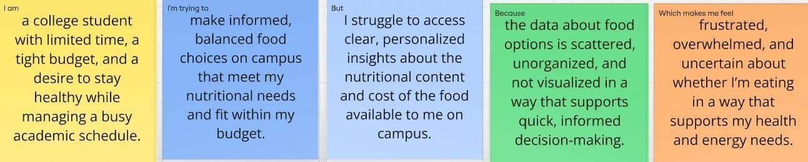

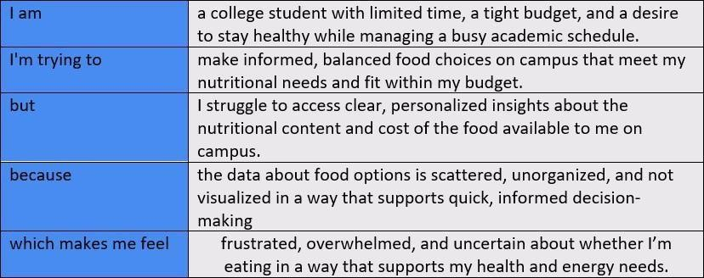

**Example:**

|  |  |  |  |  |  |
| --- | --- | --- | --- | --- | --- |
| **Problem**  **Statement (PS)** | **I am** | **I’m trying to** | **But** | **Because** | **Which makes me feel** |
| PS-1 | a college student with limited time, a tight budget, and a desire to stay healthy while managing a busy academic schedule. | make informed, balanced food choices on campus that meet my nutritional needs and fit within my budget. | I struggle to access clear, personali zed insights about the nutritiona l content and cost of the food available to me on campus. | the data about food options is scattered, unorganized, and not visualized in a way that supports quick, informed decision- making. | frustrated, overwhelmed, and uncertain about whether I’m eating in a way that supports my health and energy needs. |
| PS-2 | a university nutritionist responsible for supporting student health through meal planning and education. | identify patterns in student food choices to design better dietary strategies and recommend  healthier, more appealing meal options. | I can’t easily track or analyze large volumes of meal data or student preferenc es in a visual, actionabl e format. | the data is stored in multiple systems and lacks real- time visualization tools that can reveal trends or problem areas. | ineffective, concerned, and unable to confidently support students with data- driven dietary guidance. |